**2013**

**Government Polytechnic**

**Sorab**

Proposal for Rashtriya Uchachatar Shiksha Abhiyan

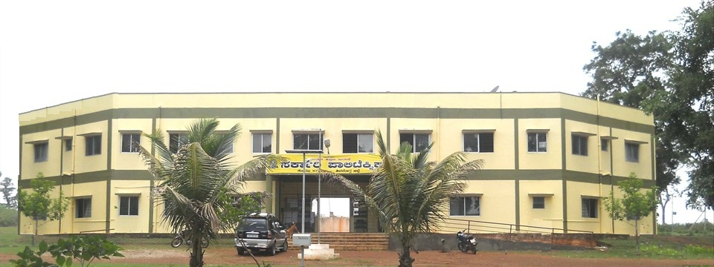

**INSTITUTIONAL DEVELOPMENT PROPOSAL**

**CONTENTS**

|  |  |  |  |
| --- | --- | --- | --- |
| **SL. NO.** | **CONTENT** | **PAGE NO** | **ANNEXURE** |
| **1** |  |  |  |
| **2** |  |  |  |
| **3** |  |  |  |
| **4** |  |  |  |
| **5** |  |  |  |
| **6** |  |  |  |
| **7** |  |  |  |

**1. INSTITUTIONAL BASIC INFORMATION**

**1.1 Institutional Identity:**

|  |  |  |
| --- | --- | --- |
| Name of the Institution | : | Government Polytechnic |
| Is the Institution approved by regulatory body? | : | YES |
| Furnish approval no. | : |  |
| Type of Institution | : | Govt. funded |
| Status of Institution | : | Constituent Institution |

**Name of Head of Institution and Project Nodal Officers**

|  |  |  |  |  |  |
| --- | --- | --- | --- | --- | --- |
| **Head and Nodal**  **Officer** | **Name** | **Phone**  **Number** | **Mobile**  **Number** | **Fax**  **Number** | **E-mail**  **Address** |
| Head of the Institution  (Full time appointee) |  |  |  |  |  |
| RUSA Institutional  coordinator |  |  |  |  |  |
| Nodal Officers for: | | | | | |
| Academic Activities |  |  |  |  |  |
| Civil Works including  Environment  Management |  |  |  |  |  |
| Procurement |  |  |  |  |  |
| Financial aspects |  |  |  |  |  |
| Equity Assurance Plan  Implementation |  |  |  |  |  |

**1.2 Academic Information:**

Diploma programs offered in Academic year 2012-13

|  |  |  |  |  |  |  |
| --- | --- | --- | --- | --- | --- | --- |
| **Sl. No.** | **Title of programs** | **Level** | **Duration (Years)** | **Year of**  **starting** | **sanctioned**  **annual Intake** | **Total student**  **strength** |
| 1 | Civil Engineering | Diploma | 3 | 1996 | 60 |  |
| 2 | Electronics and Communication Engineering | Diploma | 3 | 1996 | 60 |  |
| 3 | Computer Science and Engineering | Diploma | 3 | 1996 | 60 |  |
| 4 | Commercial Practice | Diploma | 3 | 1996 | 60 |  |

**1.3 Faculty Status (Regular/On-Contract Faculty as on March 31st, 2013)**

|  |  |  |  |  |  |  |  |  |  |  |  |  |  |  |  |  |
| --- | --- | --- | --- | --- | --- | --- | --- | --- | --- | --- | --- | --- | --- | --- | --- | --- |
| **Faculty Rank** | **No. of Sanctioned Regular Posts** | **Present Status : Number in Position by Highest Qualification** | | | | | | | | | | | | **Total Number of regular faculty**  **in Position** | **Total Vacancies** | **Total Number of contract faculty**  **in Position** |
| **Doctoral**  **Degree** | | | | **Masters**  **Degree** | | | | **Bachelor Degree** | | | |
| **Engineering**  **Disciplines** | | **Other**  **Disciplines** | | **Engineering**  **Disciplines** | | **Other**  **Disciplines** | | **Engineering**  **Disciplines** | | **Other**  **Disciplines** | |
| **R** | **C** | **R** | **C** | **R** | **C** | **R** | **C** | **R** | **C** | **R** | **C** |
|  |  |  |  |  |  |  |  |  |  |  |  |  |  |  |  |  |
|  |  |  |  |  |  |  |  |  |  |  |  |  |  |  |  |  |
|  |  |  |  |  |  |  |  |  |  |  |  |  |  |  |  |  |
|  |  |  |  |  |  |  |  |  |  |  |  |  |  |  |  |  |
|  |  |  |  |  |  |  |  |  |  |  |  |  |  |  |  |  |
|  |  |  |  |  |  |  |  |  |  |  |  |  |  |  |  |  |

**Note:**

**1.4 Baseline Data (*all data given for the following parameters to ALL disciplines*)**

|  |  |  |
| --- | --- | --- |
| **SL. No** | **Parameters** |  |
| 1 | Total strength of students in all programs and all years of study in the year 2012-13 |  |
| 2 | Total women students in all programs and all years of study in the year 2012-13 |  |
| 3 | Total SC students in all programs and all years of study in the year 2012-13 |  |
| 4 | Total ST students in all programs and all years of study in the year 2012-13 |  |
| 5 | Total OBC students in all programs and all years of study in the year 2012-13 |  |
| 6 | Number of fully functional P-4 and above level computers available for students in the year 2012-13 |  |
| 7 | Total number of text books and reference books available in library for UG and PG students in the year 2012-13 |  |
|  | Student-teacher ratio |  |
| 8 | % of UG students placed through campus interviews in the year 2012-13 |  |
| 9 | % of PG students placed through campus interviews in the year 2012-13 |  |
| 10 | % of high quality undergraduates (>75% marks) passed out in the year 2012-13 |  |
| 11 | % of high quality postgraduates (>75% marks) passed out in the year 2012-13 |  |
| 12 | Number of research publications in Indian refereed journals in the year 2012-13 |  |
| 13 | Number of research publications in International refereed journals in the year 2012-13 |  |
| 14 | Number of patents obtained in the year 2012-13 |  |
| 15 | Number of patents filed in the year 2012-13 |  |
| 16 | Number of sponsored research projects completed in the year 2012-13 |  |
| 17 | The transition rate of students in percentage from 1st year to 2nd year in the year 2012-13 for : (i) all students (ii) SC (iii) ST (iv) OBC |  |
| 18 | IRG from students’ fee and other charges in the year 2012-13 (Rs. In lakh) |  |
| 19 | IRG from externally funded R&D projects, consultancies in the year 2012-13 (Rs. in lakh) |  |
| 20 | Total IRG in the year 2012-13 (Rs. in lakh) |  |
| 21 | Total annual recurring expenditure of the institution in the year 2012-13 (Rs. In lakh) |  |

**SWOT ANALYSIS**

SWOT Analysis was carried out by taking into consideration the views of various stake holders viz. faculty, students, administrative staff, Group-D employees, and few External Entities. SWOT analysis was carried department wise and was consolidated to the institutional SWOT.

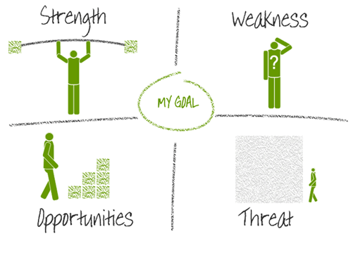

**The following are the details of SWOT Analysis,**



**STRENGTHS**

1. Institution is located in an environmental friendly space with spacious land (25 Acres).
2. Cost effective, Ragging free, Quality education.
3. Competent and Enthusiastic faculty and good student teacher relationship.
4. Excellent Academic performance.
5. Creative and Competitive students.
6. Excellent regional reputation.
7. Executing centrally sponsored schemes like **CDTP, MODROBS** and **NSS**.
8. CCTECH and Alumni Association.
9. Carrying out Equity initiatives as per government norms.
10. AICTE approval for three new courses viz. Architecture, Mechanical and Automobile Engineering.

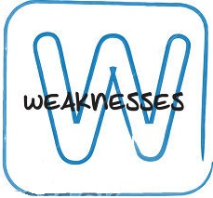

**WEAKNESS**

1. Lack of infrastructure viz. Buildings, Classrooms, Laboratory Equipments and furniture’s.
2. Insufficient staff.
3. No research activities due to inadequate internal funding.
4. Student teacher ratio is not according to AICTE Norms.
5. Lack of Industry orientation.
6. Inadequate access to knowledge resource (Library and Digital Library).
7. No placement opportunities in campus.
8. Lack of communication skills among students.
9. Inadequate faculty development programs.
10. Inadequate facility for institutional consultancy activities.
11. Inadequate facility for remedial coaching and co-curricular activities.
12. Inadequate training programs for administrative staff.
13. Lack of infrastructure and Learning resources for disabled group.
14. Not able to get sanction for AICTE approved courses.
15. Lack of student centric activities.





**OPPORTUNITIES**

1. Wide openings in public as well as private sectors.
2. Better Hands-on Experience helps self employability.
3. Local consultancy services.
4. Opportunities for conducting skill development programs, Job fairs, career guidance program, technical Exhibitions.
5. Quality Improvement Programs for faculty development and Administrative staff training.
6. To start new courses.
7. Conducting remedial /coaching classes for Exams/Competitive Exams.
8. Industry institute collaboration.
9. Provision for Providing infrastructure and Learning facilities for the disabled.
10. Increase in gross enrollment ratio (GER), Employability by addition of three new courses.





**THREATS**

1. Frequent change in government policies.
2. Staff pattern not approved for new courses and attracting faculty is a big Challenge for rural and backward area.
3. Decline in the overall quality of student intake due eligibility criteria.
4. Present system of curriculum not in line with rapid change in technology.
5. Institution located in a rurally backward area with minimum basic facilities.

**Objectives based on SWOT analysis:**

|  |  |  |  |  |  |
| --- | --- | --- | --- | --- | --- |
| **Sl. No.** | **Objective** | **Strength** | **Weakness** | **Opportunity** | **Threat** |
| 1. | Infrastructure Development | Spacious land of 25 Acres. **[1]** | Lack of Infrastructure. **[1]** | Better Hands-on Experience. **[1]** | Institution located in a rurally backward area. **[5]** |
| 2. | Research and Development | Creative and Competitive students. **[5]** | No research activities. **[3]**  Lack of Industry orientation. **[5]** | Industry institute collaboration. **[8]** | Institution located in a rurally backward area. **[5]** |
| 3. | Faculty Development | Competent and Enthusiastic Faculty. **[3]** | Inadequate faculty development programs. **[9]** | Q.I.P for faculty development. **[5]** | Attracting faculty is a big Challenge for rural and backward area. **[2]** |
| 4. | Employability | Excellent Academic performance. **[4]**  Creative and Competitive students. **[5]**  Excellent regional reputation. **[6]** | Insufficient staff. **[2]**  No placement opportunities in campus. **[7]**  Lack of communication skills among students. **[8]** | Opportunities for conducting skill development programs, Job fairs, career guidance program. **[4]**  Industry institute collaboration. **[8]** | Institution located in a rurally backward area. **[5]** |
| 5. | Institutional Reforms | Executing centrally sponsored schemes like **CDTP, MODROBS** and **NSS**. **[7]** | Lack of infrastructure. **[1]**  Insufficient Staff. **[2]**  Inadequate training programs for administrative staff. **[12]** | Administrative staff training. **[5]** | Institution located in a rurally backward area. **[5]** |
| 6. | Academic Reforms | Excellent Academic performance. **[4]**  Creative and Competitive students. **[5]**  Excellent regional reputation. **[6]** | Student teacher ratio is not according to AICTE Norms. **[4]**  Inadequate access to knowledge resource (Library and Digital Library). **[6]**  Lack of communication skills among students. **[8]**  Inadequate facility for remedial coaching. **[11]** | Conducting remedial /coaching classes for Exams/Competitive Exams. **[7]** | Attracting faculty is a big Challenge for rural and backward area. **[2]** |
| 7. | Equity initiatives | Carrying out Equity initiatives as per government norms. **[9]** | Lack of infrastructure and Learning resources for disabled group. **[13]** | Provision for Providing infrastructure and Learning facilities for the disabled. **[9]** | Institution located in a rurally backward area. **[5]** |
| 8. | New Courses | AICTE approval for three new courses. **[10]**  Spacious land of 25 Acres. **[1]** | Lack of Infrastructure. **[1]** | Increase in (GER), Employability by addition of three new courses. **[10]** | Staff pattern not approved for new courses. **[2]** |

**Objective versus Action Plan:**

|  |  |  |
| --- | --- | --- |
| **Objectives** | **Specific Objectives** | **Action Plan** |
| Infrastructure Development | Modernization and strengthening of Laboratories. | * Furnishing the Laboratories to required Standards. * Procurement of necessary equipments. |
| Establishment of new Laboratories. | * Constructing new Laboratory buildings. * Setting up of laboratories. |
| Modernization of classrooms | * Procurement of modern teaching aids viz. interactive boards, white boards, individual chairs and projects. |
| Updation of Learning Resources | * Providing access to modern learning aids like internet, national and international journals. |
| Modernization/improvements of supporting departments | * Modernization of science Lab and setting up of English Lab |
| Modernization and strengthening of libraries | * Procurement of additional text books and reference books. * Setting up of digital library. |
| Minor Civil Works | * Increasing access to portable water and modernization of sanitation facilities. * Construction of compound wall to institution. |

|  |  |  |
| --- | --- | --- |
| **Objectives** | **Specific Objectives** | **Action Plan** |
| Research and development | Enhancement of R&D | * Setting up of Innovation club. * Conducting workshops and seminars for motivating the students to carry out research activities. * Encouraging the students to participate in technical festivals. * Setting up of student clubs for providing outlets to explore professional interests and opportunity for industry interaction |
| Institutional consultancy activities | * Scaling up of laboratories to the required standards. * Setting up of consultancy cell to facilitate consultancy activities. |

|  |  |  |
| --- | --- | --- |
| **Objectives** | **Specific Objectives** | **Action Plan** |
| Faculty Development | Faculty Development | * Conducting workshops and seminars in emerging technology. * Organizing seminars with the help of industry to improve the technical competence of the faculty. * Organizing symposiums in leadership qualities, professional ethics and demonstrate congruence between their values and actions. * Encouraging the faculty to continue their participation in innovation and services. |

|  |  |  |
| --- | --- | --- |
| **Objectives** | **Specific Objectives** | **Action Plan** |
| Institutional Development | Procurement and Academic activities. | * Appointing nodal officers for academic and procurement activities. * Facilitating technical assistance to nodal officers. |
| Institutional management capacity enhancement. | * Providing infrastructure for office administration. * Leadership development programs for Educational Administrator. * Conducting programs for professionalizing academic administration for the administrative staff. |

|  |  |  |
| --- | --- | --- |
| **Objectives** | **Specific Objectives** | **Action Plan** |
| Academic reforms. | Creation of new departments/courses | * Getting sanction for the AICTE approved new courses. * Filling up of faculty positions for the new courses. * Infrastructure development for the new courses viz buildings, laboratories. |
| Enhanced Interaction with Industry | * Organizing seminars and workshops with the help of industry. * Organizing industry visits. * Motivating students to find innovative solutions for local industry problems. |
| Student support activities | * Organizing student clubs for providing outlets to explore personal and professional interests. * Conducting career guidance, personality development, entrepreneurship development programmes. * Providing academic, individual guidance and counseling sessions. * Conducting symposiums for students in time management, problem solving and ethical leadership qualities. * Encouraging the students to practice academic honesty in the spirit of inquiry and discovery. * Conducting technical festivals, sports meet and cultural festival. |